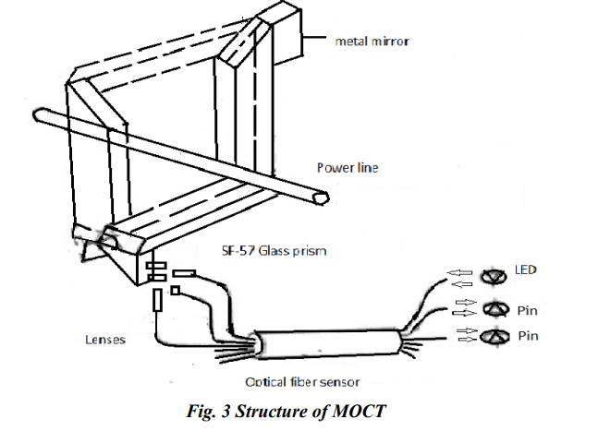

Figure 3 shows the structure of this MOCT. The optical sensor consists of two separate clamp-on parts. In each part of the device, linearly polarized light is arranged to pass through the optical glass prism to pick up the Faraday rotation signal. The polarization compensation technique is applied at each corner of the prisms, so that the light passing through the prism remains linearly polarized. At the other end of the prism, a silver mirror reflects the light beam so that light beam comes back to its sending end via the same route while accumulating the Faraday rotations



The two halves can be assembled around the conductor. Thereby, the rotation angles from the two halves of the sensor [Fig.2.3.2(a)] are added up in the signal processing unit so that the total rotation angle (q 1+q 2 ) is the same as the rotation angle q from the optical path shown in Fig2.3.2(b), which is two turns around the conductor[7].

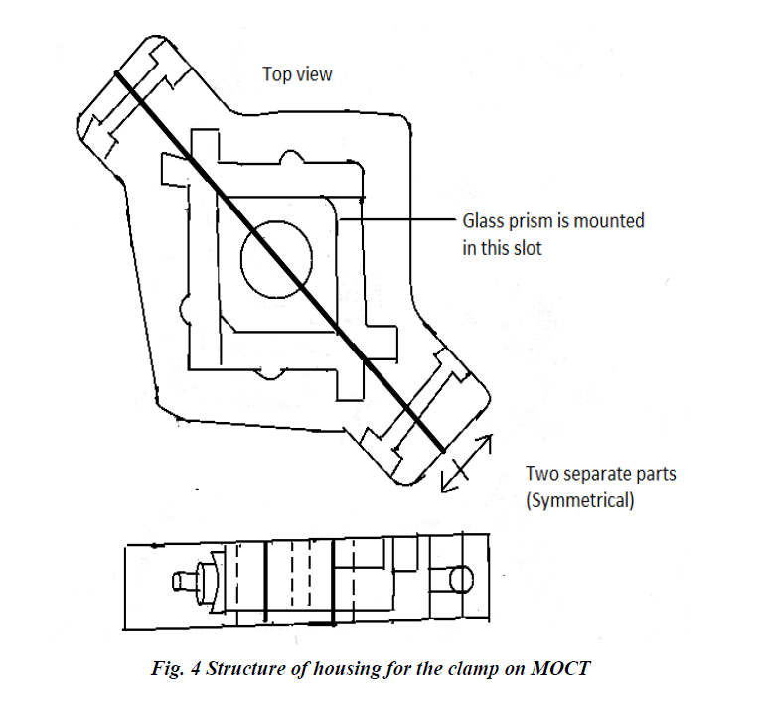

Fig. 4 shows the structure of the housing for the clamp-on MOCT. The optical glass prism polarizes, and lenses are completely sealed in the housing by epoxy, so that they are free of environmental hazards such as dust and moisture. This structure avoids the use of magnetic material to concentrate the magnetic field as found in some other MOCT design and Hall Effect current measurement devices. There for it is free from the effect of remanent flux, which could affect the accuracy of the current measurement [5].